**Room escape**

Room escape is a popular game across the world, both as live-action role-playing and on platforms like PC, IOS and Android.

**Demographics:**

* In a survey Europe appeared to have the biggest number of facilities for live-action role playing room escape games, with an overall 52% of all the participants, followed by North America who followed with 44%.
* Gender wise, 71% percent of people who go to play room escape in groups are mixed genders, an equal amount of men and woman are interested in Room Escape games.
* Age wise, the largest amount of players are Adults (over 21), followed by young adults (under 21).

**Mechanics (online game)**

* Role-playing
* Puzzle solving
* Always moving
* Single player
* Item picking

Usually in room escape games, you either escape one room or a building. Some variations to the game exist, but most, if not all games include the following:

* Items to be collected in the room
* Moving objects to find hidden object inside the room
* Finding combinations/passwords/codes for locked objects in the room
* Minigames with one possible solution
* Simple artwork which lacks any immersive quality (for free online game, an exception is the buy to play game The Room, available on Pc, IOS and Android)
* Simple or lacking narratives, no reason given for escaping the room

Example:

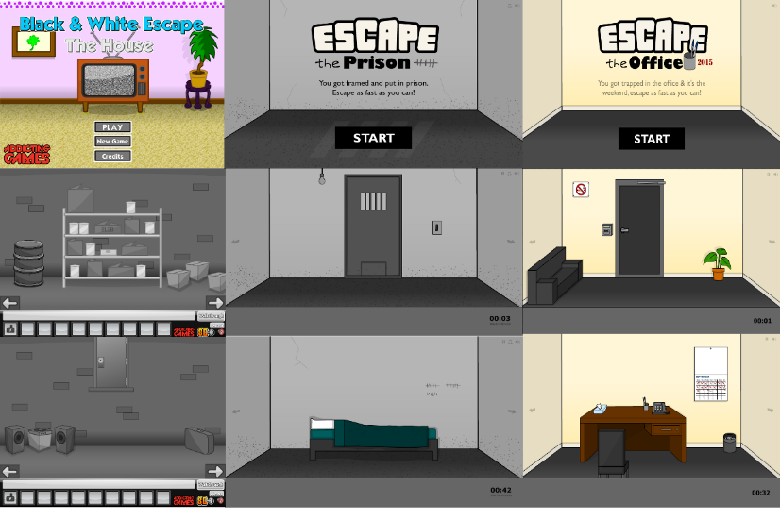

I’ve come up with a couple possible ideas regarding a Room escape game, with puzzles that can be solved in multiple ways:

* Scenario: you’ve been kidnapped and wake up in a locked room, you don’t know where you are. Turns out you are in the house of a serial killer/murderer, who has a never-ending list of mental illnesses. One of them makes him paranoid, therefore no doors have locks and keys, but rather a series of unique puzzles with multiple solutions. You need to find a way to escape(the win condition).
* You can find hints and narrative indicators of who your kidnapper is, and therefore you can uncover more about the world you find yourself in.
* There are multiple ways you can escape (find and fix a phone and call for help, escape by fixing the boat by the lake, fix a car and drive off, get a bicycle etc. No matter which way you choose to escape, you will have to find items and solve puzzles.)
* There can be an online server where players can compare how long it took them to escape compared to other players.
* There can be an achievement list at the end, and depending on the way you chose to escape, you unlock an achievement.
* The house can be a cabin by the lake, with multiple levels and a basement. More advanced/complicated ways of escaping will force you to adventure further, outside of your comfort zone to achieve the desired ending.
* The aesthetics of the game, and the artwork will be complicated and quite descriptive, diving in quite mature themes to appeal to a target audience (adults and young adults) and therefore will be immersive, helping the player connect to the character they’re playing as.
* All these elements will come together in an intense playthrough, building frustration and anxiousness from the player, hopefully achieving hard and serious fun, resulting in fiero when the player wins the game, creating a memorable player experience.

I’ve compelled a couple moodboards of possible art styles/aesthetics for the game, completely different from the games I’ve seen so far online. The main idea I wanted to show in this moodboard is the “show, don’t tell” principle, giving the player an idea of what the game is like, as well as adding details that will give the game a finished, polished look.

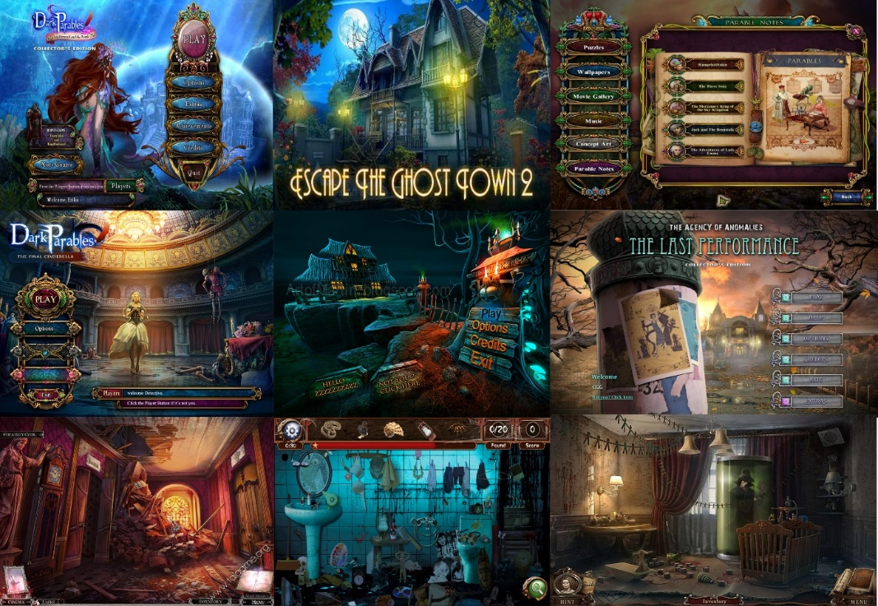

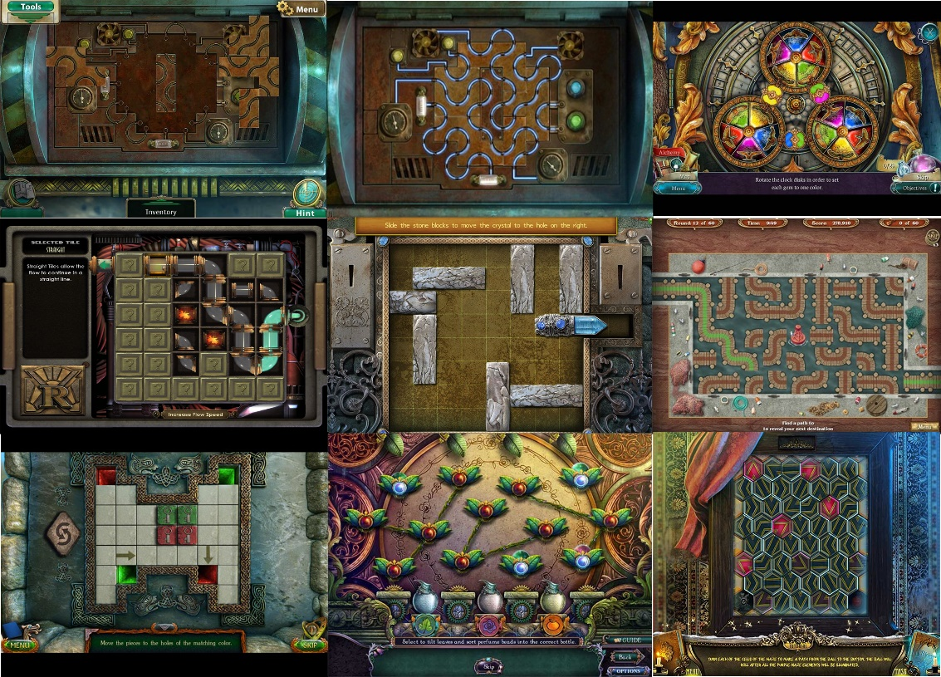I’ve also made a moodboard with different minigames I’ve seen that haven’t been used used in Room escape games before. These minigames are the one’s I’d suggest we should use instead of the typical lock and key and password/code mechanic.

References

2015, E. (2015). *Escape the Office 2015*. [online] AddictingGames.com. Available at: http://www.addictinggames.com/puzzle-games/escape-the-office-2015-game.jsp [Accessed 1 Oct. 2017].

4 keys to fun Nicole Lazzaro. (2017). [image] Available at: http://nicolelazzaro.com/wp-content/uploads/2012/03/4_keys_poster3.jpg [Accessed 1 Oct. 2017].

Abyss: the wraiths of Eden. (2017). [image] Available at: https://wiki.artifexmundi.com/download/attachments/13205901/Screenshot001.jpg?version=1&modificationDate=1351172886120&api=v2 [Accessed 30 Sep. 2017].

Abyss: the wraiths of Eden. (2017). [image] Available at: https://www.download3k.com/article_images/0/1219/full_3_ab7aa56966fdf45b321415a585321a30.png [Accessed 30 Sep. 2017].

Big City Adventure Barcelona. (2017). [image] Available at: http://www.rgamereview.com/wp-content/uploads/2015/06/New-Hidden-Object-PC-Game-June-2015-Big-City-Adventure-Barcelona-Puzzle.jpg [Accessed 1 Oct. 2017].

Bioshock hacking. (2017). [image] Available at: http://www.wurb.com/stack/wp-content/uploads/2010/11/bioshock-hack.png [Accessed 30 Sep. 2017].

Dark Parables Jack and the Sky kingdom. (2017). [image] Available at: http://www.mobygames.com/images/shots/l/717292-dark-parables-jack-and-the-sky-kingdom-collector-s-edition.jpg [Accessed 1 Oct. 2017].

Dark Parables The Final Cinderella. (2017). [image] Available at: https://i.pinimg.com/originals/78/e7/f4/78e7f4b94b49187e3e23772d3441ecbd.jpg [Accessed 1 Oct. 2017].

Dark Parables The Little mermaid and the purple tide. (2017). [image] Available at: http://1.bp.blogspot.com/-2IS0zkEMUFE/VHZo04a0l7I/AAAAAAAAy28/WmNrQxHFZq8/s1600/DarkParables_TheLittleMermaidAn%2B2014-10-31%2B10-59-28-10.jpg [Accessed 1 Oct. 2017].

Escape the ghost town 2. (2017). [image] Available at: http://1079638729.rsc.cdn77.org/androidgame_img/escape_the_ghost_town_2/real/1_escape_the_ghost_town_2.jpg [Accessed 1 Oct. 2017].

Grim Tales Bloody Mary. (2017). [image] Available at: https://static.taigame.org/image/screenshot/201308/grim-tales-bloody-mary-collectors-edition-5.jpg [Accessed 1 Oct. 2017].

hidden object game. (2017). [image] Available at: https://i.pinimg.com/originals/62/d5/2b/62d52b9702ec84f5d16f0587ccd14445.png [Accessed 1 Oct. 2017].

hidden object horror game. (2017). [image] Available at: http://d2.alternativeto.net/dist/s/24e4cc8a-0705-e211-a334-0025902c7e73_2_full.jpg?format=jpg&width=1600&height=1600&mode=min&upscale=false [Accessed 1 Oct. 2017].

horror game. (2017). [image] Available at: https://images-na.ssl-images-amazon.com/images/I/C1WmKoLqloS.png [Accessed 1 Oct. 2017].

House, B. (2016). *Black & White Escape: The House*. [online] AddictingGames.com. Available at: http://www.addictinggames.com/puzzle-games/black-and-white-escape-house-game.jsp [Accessed 1 Oct. 2017].

Long Island Eternal Storm. (2017). [image] Available at: http://www.gamehouse.com/blog/wp-content/uploads/2016/01/Lost-Island-Eternal-Storm-Mini-Game-Solution-Mini-Game-Solution-6.jpg [Accessed 30 Sep. 2017].

Lost Grimoirea Stolen Kingdom. (2017). [image] Available at: http://www.logler.com/media/games/download/l/lost-grimoires-stolen-kingdom/lost-grimoires-stolen-kingdom-sc3.jpg [Accessed 31 Sep. 2017].

lost lands the wanderer. (2017). [image] Available at: http://www.logler.com/media/games/download/l/lost-lands-the-wanderer/lost-lands-the-wanderer-sc3.jpg [Accessed 30 Sep. 2017].

Prison, E. (2016). *Escape the Prison*. [online] AddictingGames.com. Available at: http://www.addictinggames.com/puzzle-games/escape-the-prison-game.jsp [Accessed 1 Oct. 2017].

Mountain trap the manor of memories. (2017). [image] Available at: http://cdn-games.bigfishsites.com/en_mountain-trap-the-manor-of-memories/screen3.jpg [Accessed 30 Sep. 2017].

Nicholson, S. (2015). Peeking behind the locked door: A survey of escape room facilities. White Paper available at <http://scottnicholson.com/pubs/erfacwhite.pdf>

The last performance. (2017). [image] Available at: http://www.casualgameguides.com/games/includes/Agency-Anomalies-Last-Performance/images/Intro-01-Title-Screen.jpg [Accessed 1 Oct. 2017].